1.

*Walk in the Rain*

<https://www.youtube.com/watch?v=TfE8j22UQbk>

Related experiment (RAVE): <https://drive.google.com/file/d/1bWdtwwPoy19HA-DmuuSzU0iKe7whFQdb/view?usp=sharing>

Produced and Composed by Stone

Classified as Electronic / Indie pop

DAW used: Logic Pro

Plugin list: Serum , Keyscape , Trillan , Omnisphere , Fabfilter Pro-C , Fabfilter Pro-Q , RAVE* (independent model)

The main plugins used are Serum, Keyscape (piano), Trillan (bass), and Omnisphere (some of the pads). Samples from the KSHMR sample pack and other various packs are used for drum and other sound effects.

For remixing, I used *Fabfilter Pro-C and Pro-Q* for EQ balance and compression. For most instruments, the EQ is adjusted with a standard approach to cut low frequency, weaken the middle frequency, and boost a little higher frequency, and a compressor is used for pluck instruments and drums.

This unique rainfall sound was synthesized using an audio generation model (RAVE). RAVE (Realtime Audio Variational autoEncoder) is a neural audio synthesis model that is particularly effective for this task. I trained the model on a custom dataset of rain sounds with the goal of generating high-quality, real-time rain ambiance for applications like music production. See <https://drive.google.com/file/d/1bWdtwwPoy19HA-DmuuSzU0iKe7whFQdb/view?usp=sharing> for detail.

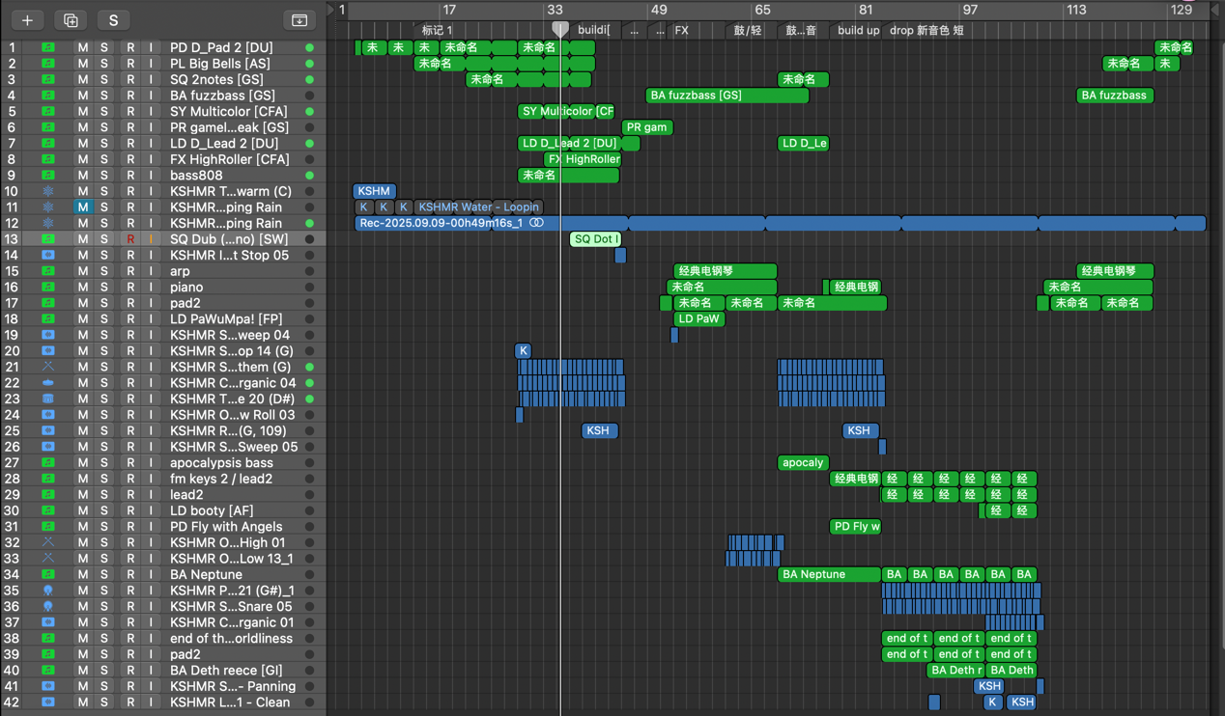

Composition Notes:

"Walk in the Rain" was first inspired as I listened to a piece of color bass, and I replicated the timbre that song used in the beginning as a starting point. My song began as an experiment in mood and texture, and I’m trying to capture the introspective and uplifting feeling of a solitary walk during a gentle rain. The track is built around warm electronic sounds, with the rhythmic foundation provided by an AI-generated rain texture. This unique rainfall sound was synthesized using an audio generation model (RAVE), which was specially trained to produce a natural, immersive, but random watering effect.

The production follows a philosophy of gradual layering. It starts minimally, allowing the melody and sound of rain to set the scene, then slowly introduces elements like the deep, melodic bass from Trilian and pads from Omnisphere. By carefully arranging plucks, arpeggios, and crisp drums from Serum and sample packs, the arrangement slowly builds in emotional intensity. The result is a purely instrumental piece that feels both electronic and organically alive, which blends synthetic production with the chaos of nature.

2.

*The Monolithic Eschaton*

<https://www.youtube.com/watch?v=ZVDCvIcgQr>4

Produced and Composed by Stone

Classified as Epic music / Orchestra

DAW used: Logic

Plugin list: Kontakt (Symphonies Series , ashlight , straylight , substance , Action Strikes , Machina , Epic Percussion 3 , signal , muse bass ) Pro-Q , sslcomp , CLA-3A , L3 Ultramaximizer

I used Kontakt for different instruments, including strings, brass, woodwinds and percussion. For specific sound libraries, I mainly used the Symphonies Series for most instruments; “ashlight”, “straylight” and “substance” are used to create the atmosphere for an epic; “Action Strikes”, “Machina”, “Epic Percussion 3”, as well as some libraries from “Symphonies Series” are used for all percussion; finally, “signal” and “muse bass” create the drastic electronic bass at the bottom of music.

For mixing, Pro-Q is added for each of the instrument groups to balance the frequencies, and *sslcomp*, *CLA-3A* and *L3 Ultramaximizer* is used in the master track to control the overall dynamic change.

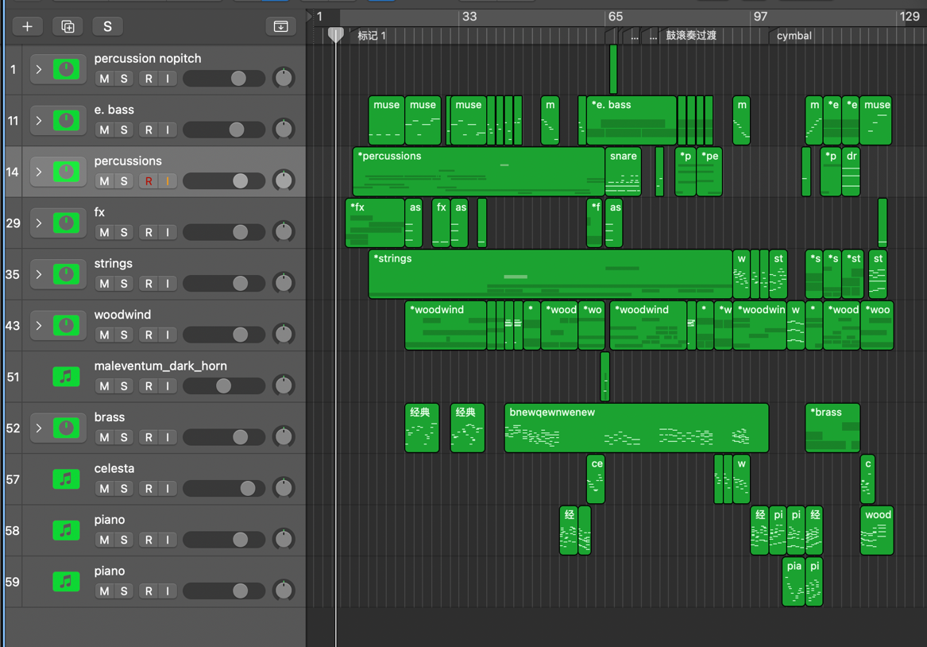

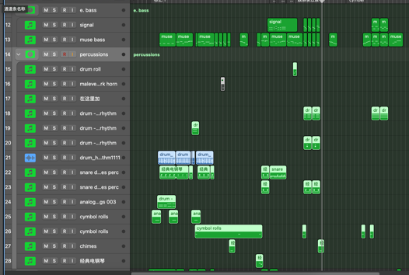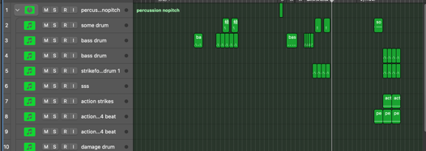

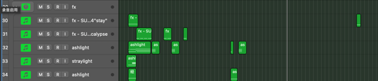

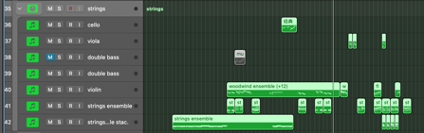电脑萤幕画面

AI 生成的内容可能不正确。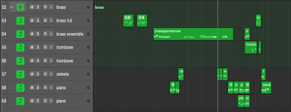

Composition Notes:

My creative motive behind "The Monolithic Eschaton" was to describe the rise and fall of a colossal entity or event sonically. In this piece, I aim to capture the sense of duality of such a phenomenon: the terrifying, overwhelming scale of its power, contrasted with a strange, underlying sense of tragic beauty through the melodies and chords.

The composition consists of a distinctive cyclical pattern. It begins with a forceful presentation of the main theme, followed by an interlude featuring lighter woodwinds and piano, which is notable for its unique and evocative harmonies. This contrast is deliberately repeated -- the music melodies to repeat the aggressive main motif, only to retreat once more into the delicate woodwind and piano passage. This choice creates a compelling push-and-pull dynamic, building tension through repetition and variation. Finally, the piece culminates in a final, grand recapitulation of the main motif and resolves into a massive and triumphant finale.

3.

*Them Changes – Thundercat (Remix)*

<https://www.youtube.com/watch?v=CSxnMbJdrfg>

Remixed by Stone

Classified as Electronic / Future Bass / Glitch Hop

DAW used: Ableton Live

Plugin list: Serum , Pianoteq8 , Trilian , Keyscape , Manipulator , Glue Compressor , Fabfilter Pro-Q , EQ eight , UVR5

I Mainly used Serum for various electronic instruments, including different basses, pads, and leads. Pianoteq8 is used for piano. Also, I added *Trilian* for bass and *Keyscape* for E.piano. *Manipulator* is used to alter the formant of the vocal, which gives it a special timbre. Vocal chop and many FX samples are used frequently in the drop section to provide the audience with a crispy feeling.

For mixing, I added some distortion and lo-fi with the vocal to exaggerate the special, unclear but interesting timbre. *Glue Compressor* is used in the master track to “glue” the sounds together by slightly weakening the dynamic differences. With most channels, *Fabfilter Pro-Q* is used to balance the frequencies. I also used the built-in EQ plugin *EQ eight* to create EQ filters that change over time, giving more vibrancy to music.

The stem of the original song *Them Changes* is extracted by *UVR5* (Ultimate Vocal Remover 5), with several models that separate stems locally and remove the echoes of the vocal. The extracted drum loop is also used in the second drop of my remix.

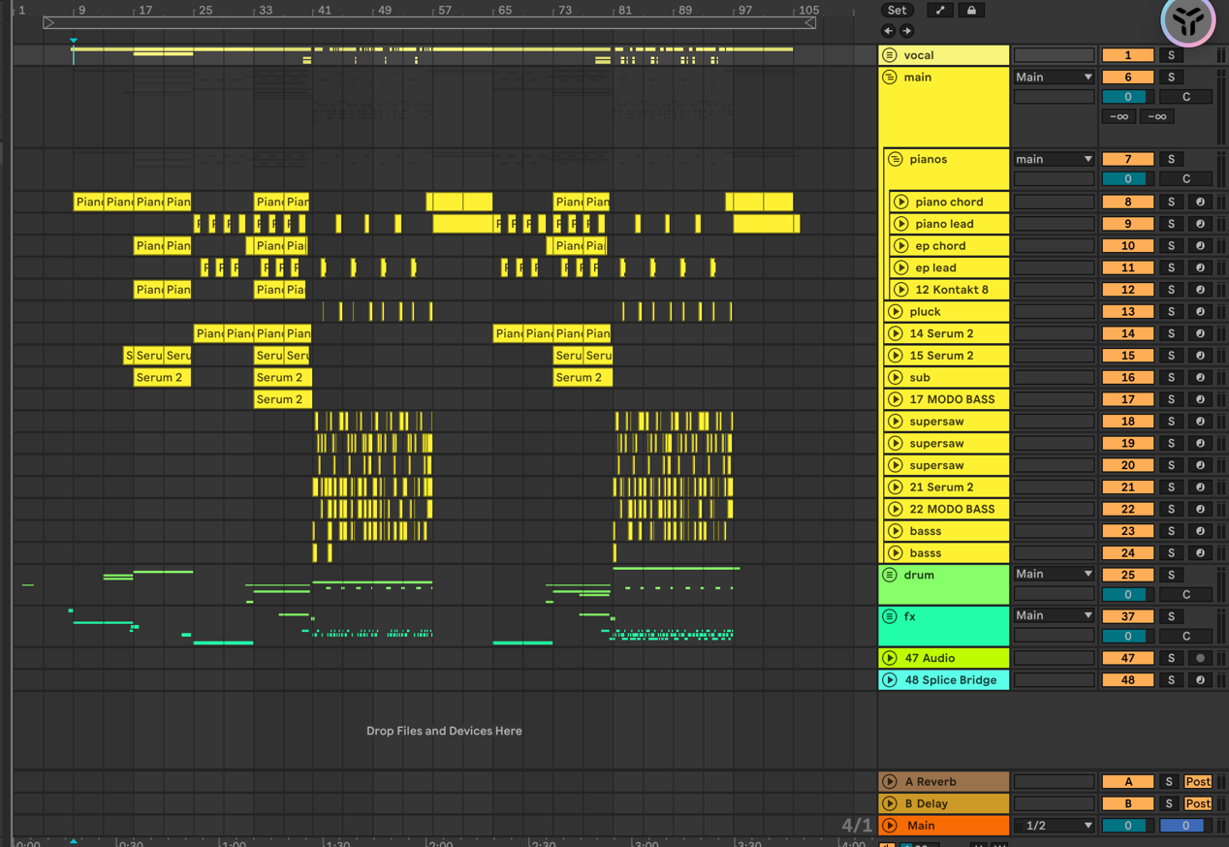

Composition Notes:

As for my first remix composition, I want to blend the obvious features of electronic music with the subtle features of jazz chords, so I could end up with something less conventional.

This remix preserves the original track's jazz-funk feeling while reinterpreting it in a contemporary electronic way. The creative focus lies in contrasting the rhythmic feel of acoustic instruments with processed vocals and a powerful electronic bass line, thereby creating a collision between tradition and modernity.

The arrangement structure emphasizes dynamic changes. The opening introduces the original rhythm through a low-key prelude, and gradually creates a tense atmosphere as the soundscape and elements are enhanced. The first climax features fragmented vocal samples and a dynamic main melody, which converges into a powerful rhythmic momentum. A quiet interlude provides a brief rest, after which the energy is once again gathered, entering the final crescendo and ultimately returning to a calm ending.

4.

*Antelucan*

https://www.youtube.com/watch?v=3uc35lOOfnc

DAW used: Logic Pro

Mainly use “high-speed” piano (from plugin *Pianoteq8* and *Keyscape*) and some violin (from *Symphonies Series* and *SWAM*) for the melody, as well as other electronic timbres (from *Serum*, *Pigment*) used for pads to create atmosphere. The piano is slightly detuned and is layered with both real piano and electronic piano. For the plug-in *SWAM*,I configured the **Expression** and **Vibrato** parameters to make the virtual instrument resemble a true human player.

For mixing, I used *Fabfilter Pro-Q and Pro-C* to provide a brief balance for the frequencies (mainly lowering the middle range) and dynamic control. A similar approach of compression using *SSLComp* and *L2 Maximizer* is used.

Plugin list: Pianoteq 8 , Keyscape , Symphonies Series , SWAM (by Audio Modeling) , Serum Pigments , Fabfilter Pro-Q / Pro-C , SSLComp, L2 Maximizer.

Classified as Electronic / Artcore

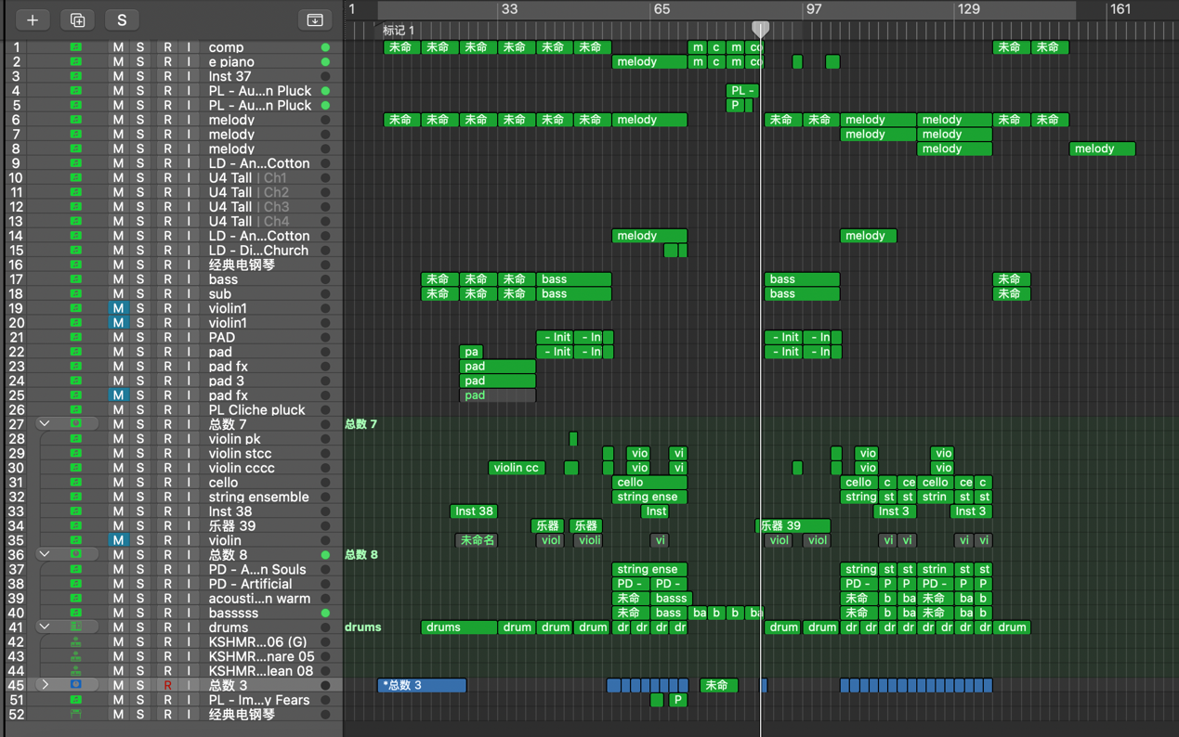

Composition Notes:

My initial motivation for creating Antelucan was to try one of the styles that often appear in rhythm games: Artcore, which blends high-speed, complex melodies with atmospheric electronic backgrounds. The creative challenge of "Antelucan" is to strike a balance between the strong technical proficiency of its "Artcore" classification and the tangible emotional atmosphere. The crazy energy comes from the melodies of the "high-speed" piano and violin, while the atmosphere cushion provides some subtle emotional enhancement. This concept is reflected in the sound of the main piano itself: by layering a real piano (Keyscape) with an electronic piano (Pianoteq8) and applying "slight dissonance", the tone is both organic, synthetic, and futuristic.

This arrangement follows the traditional structure to manage this tense relationship. It opens with an iconic piano theme, which leads to a pile-up and the first vibrant descent, where the high-speed melody is fully reflected. Then there is a contrasting interlude, with the rhythm fading away, leaving only melody and fragments to create space. Then, the track begins its second ascent and descent, culminating in the final repetition of the opening piano section, which is an outreach that takes the audience back to their initial reflective emotions.

5.

Recording & Mixing – *Back to that Day*

https://www.youtube.com/watch?v=L02-BlCWNFA

Recorded & Mixed by Stone

Genre: Chinese pop

Device used:

Microphone – Neumann U87 Ai

Audio Interface - Apollo x8

Preamp - Chandler Limited TG2

DAW used: Reaper

Placement: vocal singing in the tracking room of the studio, the microphone placed in front of the singer, about 10 centimeters distance.

space: MIC studio tracking room.

(Neumann U87 Ai sounds is mostly for vocals, and I found it sounds clear and have lots of detail for the female vocals.)

Plugin list: CLA mixhub stereo , Pro-Q 4 , S1 imager , CLA-76 , RDeEsser , ValhallaVintageVerb , SSLComp , Melodyne , L2

In this project, I record the different instruments (strings, piano and vocal) and finish mixing.

I frequently use the *CLA Mixhub stereo* to provide a standardized approach to control EQ and the compressor. *Pro-Q 4* is used as another more accurate EQ. For the strings, *S1 imager* is used to utilize the Haas effect to widen the sound. *CLA-76* is used as another compressor for melody (used for strings, piano, and vocal), and *RDeEsser* could reduce sibilant consonants in human voice. *ValhallaVintageVerb* helps build a track for Reverb. Finally, *SSLComp* and L2 is used to control the overall dynamics of the song. *Melodyne* is used to correct the singer’s pitch.

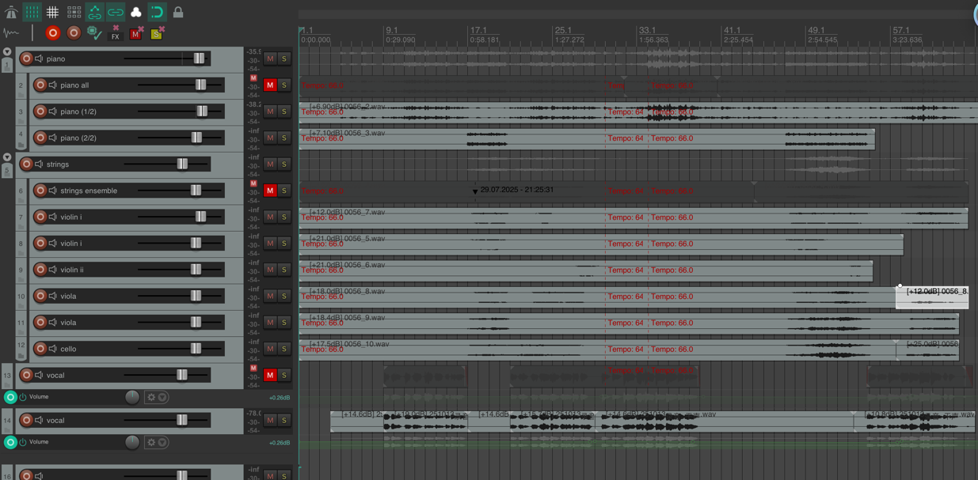

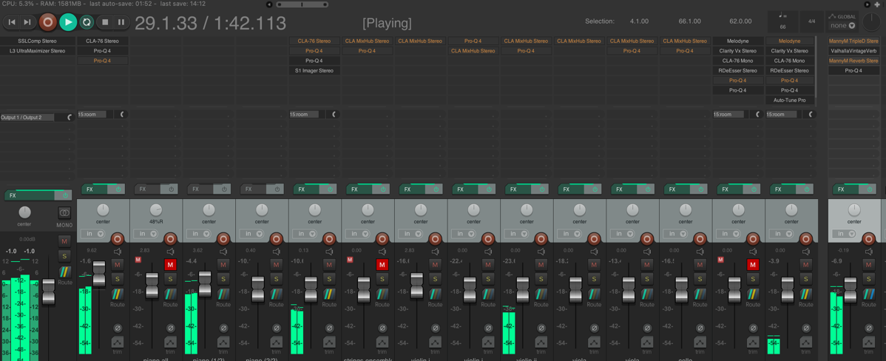

7. Mixing – *Arguing*

Equipment used:

vocal microphone: Neumann U87 Ai，

preamplifiers: focusrite ISA 428

DAW: reaper

Placement: vocal singing in the tracking room of the studio, microphone placed in front of the singer, about 10 centimeters distance.

Space: MIC studio tracking room

(Neumann U87 Ai sounds are mostly for vocals, and I found that it sounds clear and has lots of detail for the female vocals.)

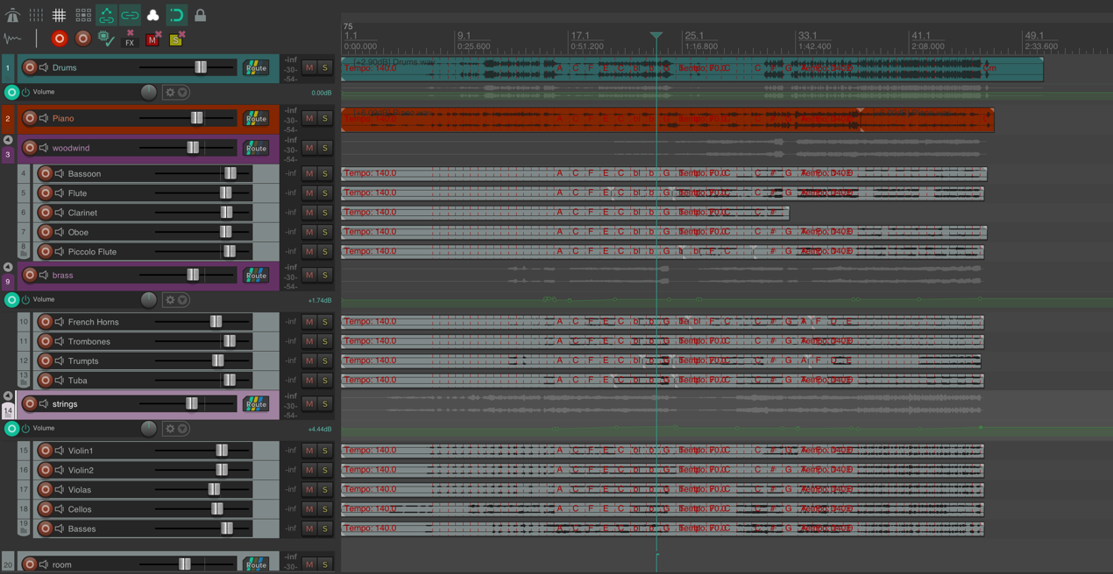

Remix Plugin list: CLA mixhub stereo , Pro-Q 4 , CLA-76 , RDeEsser , ValhallaVintageVerb , SSLComp , L3 UltraMaximizer

8. Recording – The Butterfly Lovers

Recorded by Stone

Equipment used:

Piano: Neumann km184 pair

Cello: Neumann TLM103

Violin: Direxound DS-60 Large Diaphram.

preamplifiers: Direxound MP202

DAW: Reaper

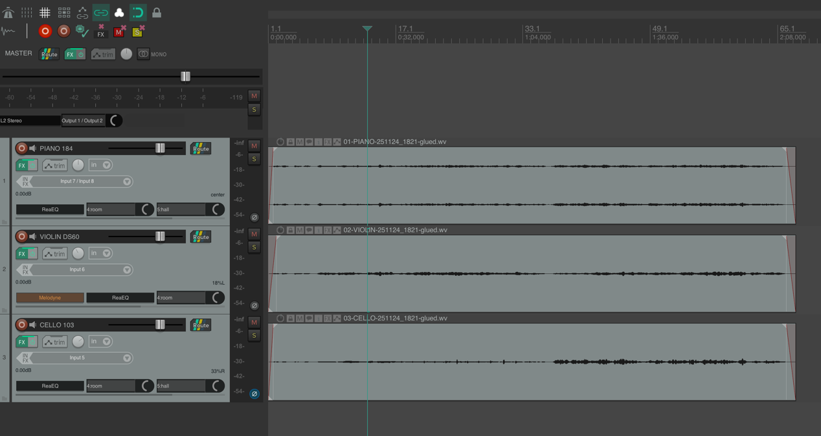

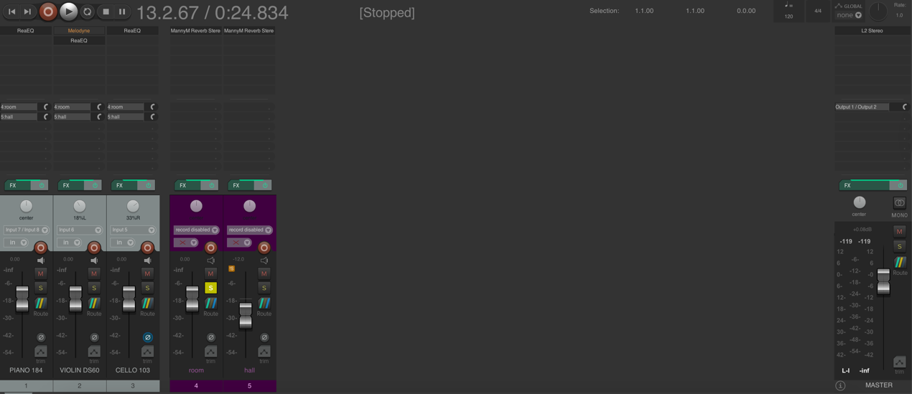

Placement: Piano in the center of the tracking room, microphones are stereo-paired AB placed at the right side of the player. Cello at the right side of the piano, a little far from the player, TLM103 microphone placed in front of the player, about 1 meter distance. Violin at the left side of the piano, near the piano player, DS-60 microphone placed in front of the player, a little higher than the player and the instrument, about 1 meter distance.

Signal processing: none.

Space: LZYY studio tracking room.

(Neumann microphones are quite well for classical music, because they sound clear and natural and also contain a very well-balanced tone. Direxound microphones and mic pres are made in China. They are all very high-quality sounding equipment with a good price range, which is why I chose to use them.)